Sharnbrook Primary History Knowledge Planner – Year 2
Topic: Castles | Disciplinary Emphasis – Historical Interpretation | Key Question – What was it like to live in a castle?
What I should already know | 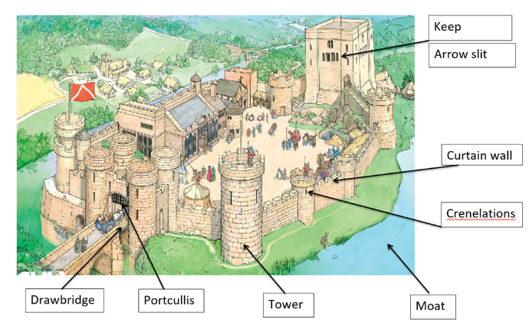  Parts of a castle  Rockingham Castle  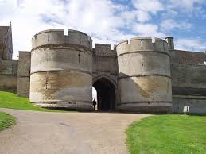 | Vocabulary
That some building are very old.  Thing can be ordered by how old they are.
  Drawbridge | A bridge made to go up and down to stop people crossing
  Portcullis | A heavy gate that is raised up and down.
  Keep | A strong tower in a castle
  Curtain Wall | Walls that protect the inside of a castle
  Arrow Slits | A thin hole in a castle wall to shoot arrows through
  Moat | A ditch filled with water that goes round a castle
  Motte and Bailey | The motte is a hill that has a keep on top and the bailey a wall or fence at the bottom.
  Chronology | The order things happen in
  Trebuchet | A siege weapon for throwing heavy objects
  Primary evidence | Something that comes from the time we are learning about
  Hastings | A town in southern England
  Stamford Bridge | A village in the north of England
  Crenelations | The up and down bits at the top of a castle wall
  King | A man who was in charge of a country
People
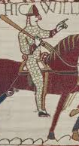  William the Conqueror | Invader of England and King 1066 – 1087. Had a lot of castles built
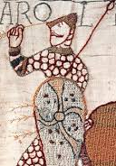  Harold Godwinson | King on England 1066
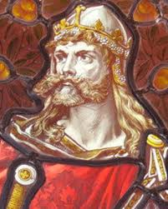  Harald Hardrada | Viking king tried to invade in 1066

Timeline |  | Historical Skills and Enquiry
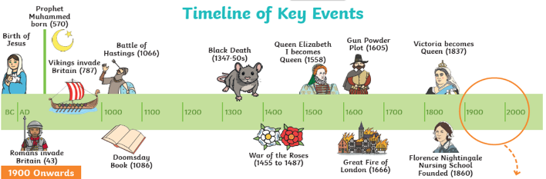 |  | I will  - compare two versions of past events;  - start to understand that there can be different versions of the same event from the past;  - observe and use pictures, photographs and artefacts to find out about the past.  - start to use stories or accounts to distinguish between fact and fiction;  - explain that there are different types of evidence and sources, such as photographic and written, that can be used to help represent the past.

