Sharnbrook Primary Knowledge Planner – Y2 History
Key Question: What was the most important change after the Great Fire of London |  | Significance
What I should already know | How much of London was destroyed  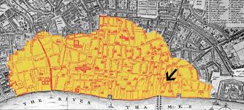  Tudor house  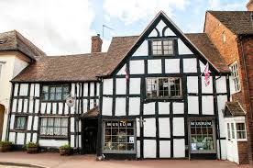 | Vocabulary
What the ovens and fires looked like. |  | - Started on Sunday 2nd September 1666 and ended on 6th.  - Thomas Farriner may not have put out his fire properly.  - It spread because many houses were made of wood and straw and built close together. A strong wind also helped spread it.  - People used squirts, bucket chains and blowing up house to try to put out the fire.  - After the fire houses were made of brick and stone  - Roads were made wider and straighter.  - Water pipes were replaced and extended.  - Local fire brigades were set up.
  River Thames | The large river that flows through London
  Wattle and daub | Walls made of woven sticks and mud, clay and straw.
  Gunpowder | A black powder that explodes when lit.
  Stuarts | Kings and Queens of England and Scotland from James I to Anne
  Flammable | When something catches fire easily.
  Change | When something becomes different to how it was before.
  Significant | Something great or important
  King | A man who rules a country.
  Key Facts
People
Thomas Farriner | Owned the bakery where the fire started.
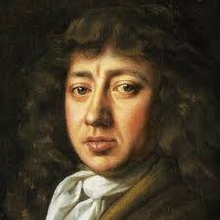  Samuel Pepys | Wrote a diary during the Great Fire of London.
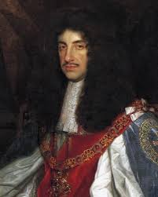  King Charles II | King during the Great Fire of London

How to be a Historian
- Know what things changed.
- Know how things changed.
- Explain why these changed.
- Explain which of the changes was the most important and why you think that.

Timeline
