Sharnbrook Primary Knowledge Planner – History Y3
Key Question: Why did the Egyptians stop building pyramids? |  | Emphasis: Cause and consequence.
People | 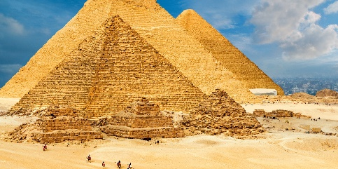  Pyramids at Giza.  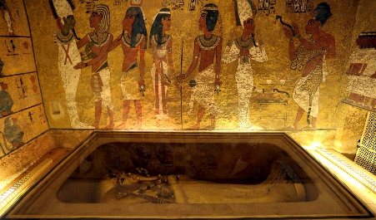  Tutankhamun’s tomb.  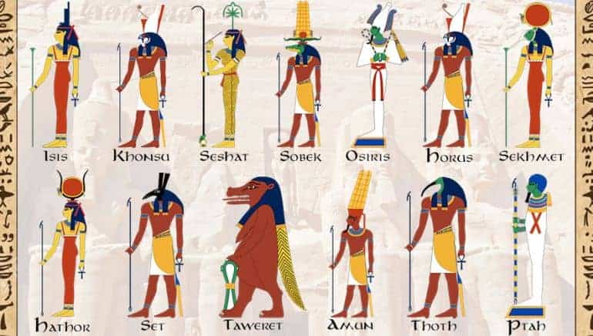  Ancient Egyptian Gods and Goddesses. | Vocabulary
  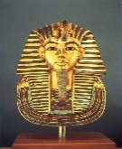 | Tutankhamun- Ancient Egyptian Pharaoh.
  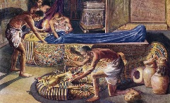 | Tomb robbers of ancient Egypt.
  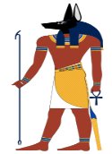 | Anubis- The God of death.
  BC | Before the birth of Jesus Christ in the religion Christianity.
  Artefact | Something that is manmade from a particular time.
  Causation | Why people acted as they did and the results of these actions taken.
  Gods and Goddesses | Figure heads of the religion of the people in the historical period.
  Pharaoh | A one person ruler in ancient Eygpt.
  Pyramid | A structure with a square of triangular base that meet at a point in ancient Egypt.
  Tomb | Large area, usually underground for burying the dead.
What I should already know? |  | How to be a historian
The children have learnt about different types of rulers e.g. Kings, Queens and Emperors. Roman, Anglo-Saxon civilisations. |  | - Can identify the reasons why pyramids were built in early ancient Egypt.  - What was wrong with pyramids?  - How was the problem solved?
Timeline |  | Key Knowledge
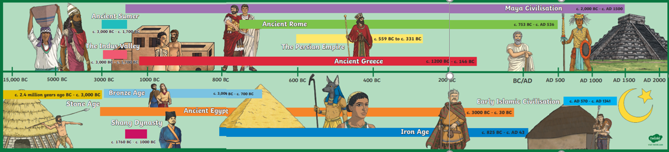 |  | Ancient Egyptians believed once they died they made a journey to the afterlife.  They were buried with food and riches that would help them on this journey.  They mummified bodied to preserve them in the afterlife.  Pyramids were built to show how important people were.  The riches buried inside pyramids meant that they were a target for tomb robbers.

