Sharnbrook Primary Knowledge Planner - History
Key Question: How do we know the Roman’s invaded Britain?​ | Year: 3 | Emphasis: Sources and evidence
What I should already know | 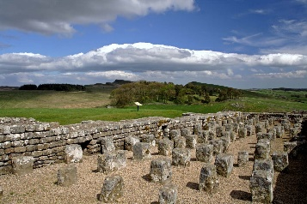  Images / maps  Hadrian’s wall    Roman Baths  Roman Roads  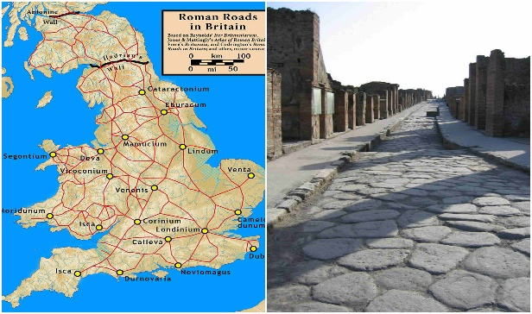 | Vocabulary
Previously looked at sources and evidence and how they tell us information about the past. Chronology is recalled from previous year groups. |  | Chronology- the order of events or dates when they happened.  Artefact- Something that is manmade from a particular time.  Primary Evidence- Something that comes from the time being studied.  AD- Anno Domini. Starts at when Christians believe Jesus was born.  Emperor- The ruler of an Empire.  Empire- Group of countries ruled by one emperor.  Invasion- Taking over a country with force.  Museum- A building with historical artifacts on display for people to see.
People |  | How to be a historian
Picts- Tribes originally from Scotland.  Romans- Mighty Empire who were in Britain for over 400 years.  Julius Caesar- Roman Emperor who first tried to invade Britain.  Emperor Claudius- Successfully invaded Britain in 43AD. |  | Can recall a range of sources and evidence that demonstrate that the Romans invaded Britain.  Is able to evidence that there was a variety of sources and evidence to show the Romans invaded Britain.  Using historical vocabulary where necessary.
Timeline |  | Key Knowledge
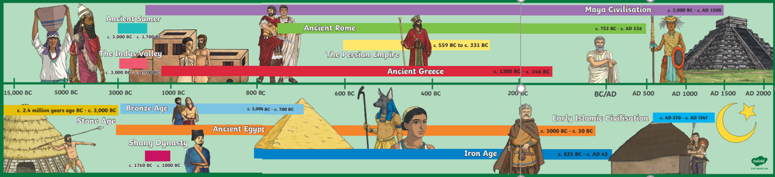 |  | Chronological/ period knowledge.  Knowledge of immediate topic/period.  Understanding of who the Romans were and why they came too Britain.  Understand a range of sources and evidence found in Britain over many years of Roman rule and identify them. They need context to identify why the Romans invaded and various evidence to demonstrate that the Romans invaded.

