J.C’s Club



Monday 8th September – Monday 2nd December 2025
For years Reception-6, 3.20pm—4.30pm

Bible stories, activities, games, crafts and snack

Sharnbrook Evangelical Church, with the kind permission of SPS

Please hand this form into the school office
Any queries contact Myles MacBean myles@sharnbrookchurch.org.uk
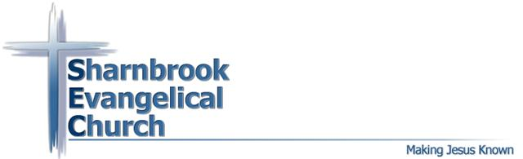


------------------------------------------------------------------------------------------------------------

JC’s Club Registration Spring-Summer 2025

Name of child/children & School Year: __________________________________________

Address (Optional): _______________________________________________________

Contact phone number during JC Club: ______________________________

We have snacks at JC’s Club. Please let us know any dietary needs/allergies we should be aware of:

________________________________________________________________________________

I give permission for photographs including my child to be used for display purposes: YES NO

I give permission for my child/children to attend JC Club:
(Please sign and print your name, thank you)

