Sharnbrook Primary Knowledge Planner – History Y3
Key Question - How different was the way of life after the Romans left? |  | Emphasis: Change and continuity
What I should already know | 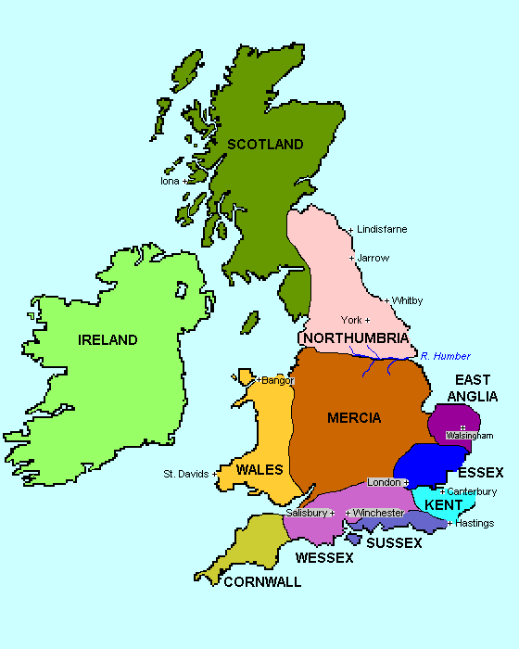  Images / maps  A map of Anglo-Saxon Britain  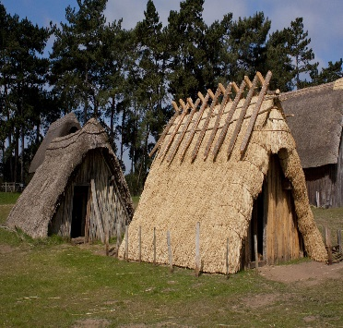  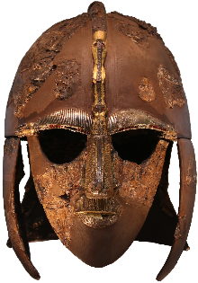  Sutton Hoo helmet  Anglo-Saxon houses | Vocabulary
What life was like in Roman Britain. (See previous knowledge organiser)
  Change | An act or process when something becomes different.
  Chronology | The order of events or dates when they happened.
  Artefact | Something that is manmade from a particular time.
  King | Male ruler of an area of land.
  Primary Evidence | Something that comes from the time being studied.
  AD | Anno Domini. Starts at when Christians believe Jesus was born.
  Kingdom | Area ruled by a king or queen.
  Community | Group of people living in an area.
People
Anglo-Saxons – Tribes from Germany, Holland and Denmark | 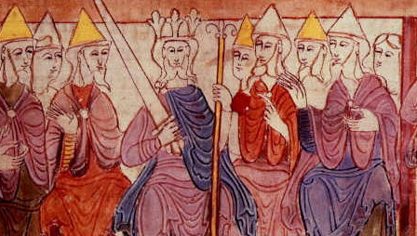
Picts – Tribes from Scotland | 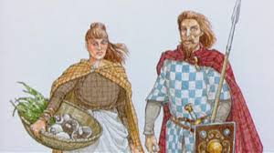
Romans – People from Italy who ruled parts of Britain for over 400 years | 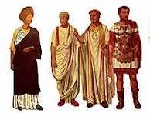
Alfred the Great | 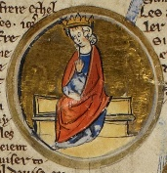

 |  | How to be a historian
- Can remember what life was like in Roman Britain.
- Can remember changes that happened when the Anglo-Saxons came to Britain.
- Start to know how much was changed and how quickly.
- Using historical vocabulary where necessary.
Timeline |  | Key Knowledge
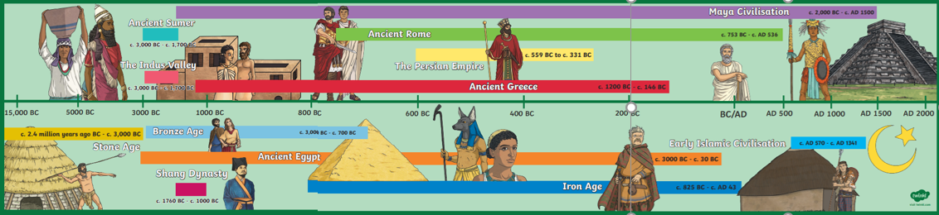 |  | Anglo-Saxons came to Britain after the fall of the Roman empire.  Anglo-Saxons lived in villages centred around a communal hall.  Anglo-Saxons ruled land differently to the Romans.

