Sharnbrook Primary Knowledge Planner – Y1 History
Key Question: What was different in the way Florence Nightingale and Mary Seacole helped the soldiers? |  | Similarities and differences
What I should already know |  | Vocabulary
  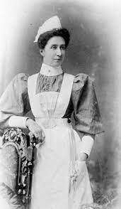  Victorian nurse |   Nurses today
  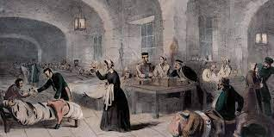
  The hospital at Scutari
The past is something that has already happened.
  In the past | Something that has already happened.
  In the present | Something that is happening now
  different | Not the same.
  event | When something happens, especially if it is important.
  nurse | Somebody who is trained to look after sick or hurt people.
  soldier | A person in the army.
  patient | Someone who is being looked after because they are hurt or sick.
People
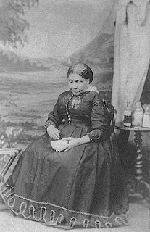  Mary Seacole | 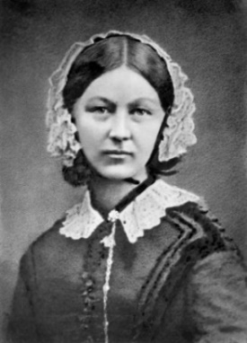  Florence NIghtingale

Timeline |  | How to be a Historian
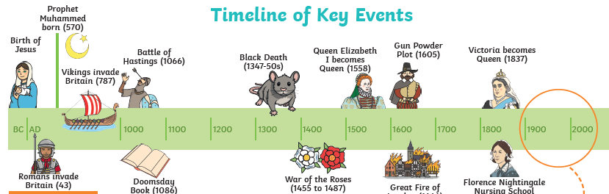 |  | - To know how Florence and Mary helped the soldiers.  - To know some of the things that Mary and Florence did that were the same.  - To know some of the things that they did that were different.

