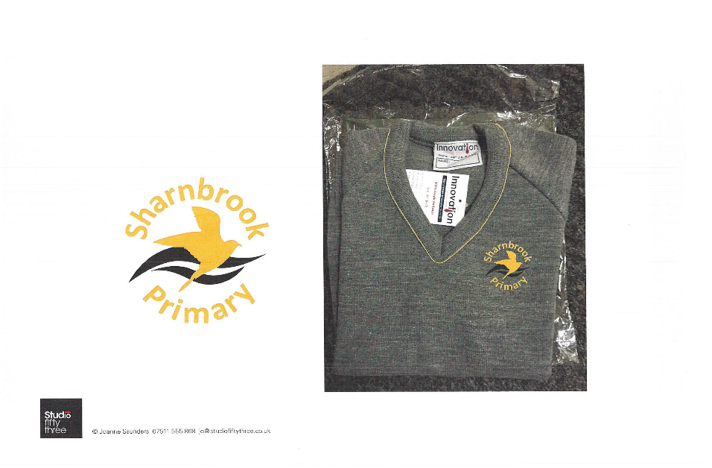Sharnbrook Pre-school

Tel: 01234 781328

**Penguins Newsletter – May 2025**

**Dear Parents/ Carers,**

The Summer term has begun, and we are all looking forward to some exciting events planned with the warmer weather in mind. May we take this opportunity to welcome our new Penguins and hope they are feeling settled. If you have any questions, please do ask; we are a friendly team willing to help in any way we can to make your children feel happy and confident coming to Preschool.

Our theme for this half term is

**“On the Move”**

Accompanying this newsletter is a Family Fun page of activities to do with your children at home, to develop further their understanding of journeys. Also included is some information about healthy lunchboxes.

We always enjoy hearing about what you have been doing at home with your children. It is very helpful if you can complete the attached My News sheet with words or pictures informing us about events or activities from home. This will in turn help us to plan relevant activities for your children at Preschool. It also provides opportunities for your child to gain confidence and fluency speaking in front of a large group.

**Summer weather**

With warmer weather on the horizon please could we remind you to check your child has a named sun hat with them and a water bottle. A complete change of clothes in their bag is also very useful because there is more water/mud kitchen/messy play in the outdoor area as the weather improves and we spend more of our day outside. The children also need to wear suitable shoes to play safely outdoors and a summer coat to be prepared for the changeable British weather. Thank you to all the parents who returned the sun cream letter. If you opted to provide your own sun cream, please ensure it is in your child’s bag and labelled. On sunny days if you could apply some sun cream before your child comes to Preschool and we will re-apply cream at lunchtime. Thank you for your help in this essential but time-consuming task.

**Learning our names for children moving into a Reception class in September**

The children are learning to recognise their names by looking at the shapes of the letters. Gradually we will show them how to write the letters and ask them to have a go themselves. This is something you can do with them at home. Remember to use a capital letter only for the first letter, the other letters need to be in lower case formation. We also say the letter sound as they write each one and not the letter name. Please do ask for clarification if you are unsure – it is much harder to unlearn something, and they will make faster progress if they learn it correctly right from the start. We also want them to develop a good tripod grip which you can also encourage at home – see attached handout for correct letter formation and pencil grip.

**Interactive Learning Diary**

Please do take another look at the Interactive Learning Diary it contains many observations of your child’s day at Preschool and the children really enjoy looking at the photographs and remembering all their learning – we have been so busy this year.

Another good way to keep informed about Preschool news and events is to take a look at the Sharnbrook Primary website. There you will discover a wealth of information about the school and each class has their own page for specific information. Simply type **www.sharnbrookprimary.beds.sch.uk** into your search bar.

**Dates for your Diary**

Monday 26th May – Friday 30th May – Half term (No Preschool)

Monday 2nd June and Tuesday 3rd June – Balance Bikeability for Preschool children who will transition into a Reception class in September

Wednesday 18th June 6.00pm – 7.00pm – New Parents Evening for children joining the Reception class in September

Friday 27th June – Preschool Trip to Marston Vale Forest School – all children invited to attend

Tuesday 1st July and Wednesday 2nd July – Transition mornings for children moving to the Reception class in September

Friday 4th July – Penguins Sports Morning – all children invited to attend

Friday 11th July – Fun Afternoon and celebration with parents for Penguins moving on to start school in September

Friday 18th July – End of Summer term

Many thanks for your continued support with your child’s Preschool education. If you have any questions do ask a member of the team, we are here to help.

Thank you

The Pre-school Team