Puffins’ Transition Timetable
 | Morning  Work | 9.00-9.15 | 9.15-10.15 | 10.15-10.30 Play | 10.30-11.30 | 11.30-11.50 | 11.50-11.55 Poetry | 12.00-1.00 Lunch | 1.00-2.00 | 2.00-2.15 Play | 2.15-3.00 | 3.00.3.15
Tue | Register  Story   |  | Mrs Eremita shares information about herself  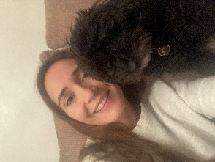Short Puffin Powerpoint look at map of the UK show Scotland.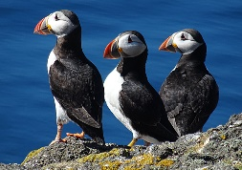 |  | Puffin Peter by Petr Horacek  Read book  Puffin craft for display  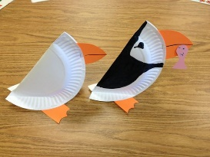 | Reading and Phonics Groups |  |  | Handprints for door   |  | Puffin Peter 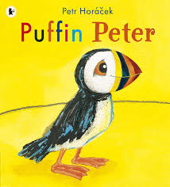 | Story
Wed | Register  Story |  | Mrs Hoog shares information about herself   Puffin Peter by Petr Horacek |  | Birthday cards   | Reading and Phonics Groups |  |  | PE  |  | Puffin Peter by Petr Horacek | Assembly

