Sharnbrook Primary Knowledge Planner – Y2 History
Key Question: How was Earnest Shackleton’s voyage different to Matthew Hensons? |  | Similarity and difference
What I should already know | 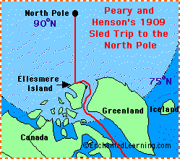  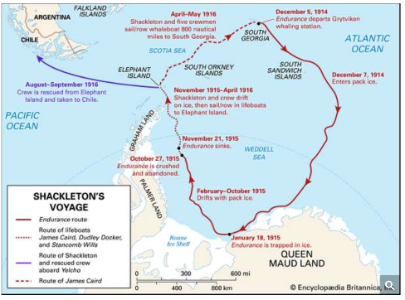  A map of Shackleton’s journey A map of Henson’s journey  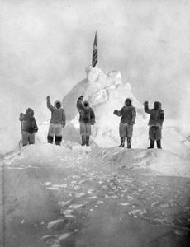  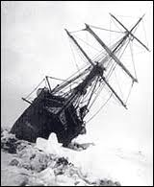  The Endurance stuck in pack ice Henson at the North Pole | Vocabulary
In Y1 the children have used first-hand accounts, photographs and books as sources of evidence.
  South Pole | The furthest you can go south on the globe.
  Antarctica | A continent around the South Pole.
  Arctic | The northern most area in the world
  Endurance | Shackleton’s ship.
  North Pole | The furthest you can go north on the globe
  Frostbite | Skin that has been damaged because it is so cold.
  Pack ice | A large piece of floating ice made up of smaller pieces being squashed together.
  South Georgia | A small island in the Atlantic Ocean.
  Elephant Island | An island off the Antarctic coast.
  Lifeboat | Small boats kept on a ship in case of emergencies.
  Drifted | Carried along by water.
  Hazardous | Dangerous.
  Bitter | Very cold.
  Inuit | Native people of the Arctic regions
  Native | People who come from that place
  Similar | Things that are alike but not the same
People
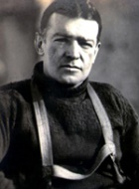 | Earnest Shackleton  Leader of the 1914 expedition to the South Pole
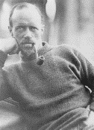 | Frank Wild  Second in command of the 1914 expedition to the South Pole
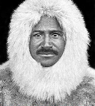 | Matthew Henson  The first person to walk on the North Pole in 1909.
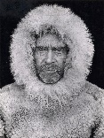 | Robert Peary  The leader of the 1909 expedition to the North Pole

Timeline |  | How to be a Historian
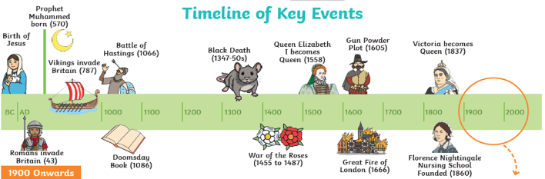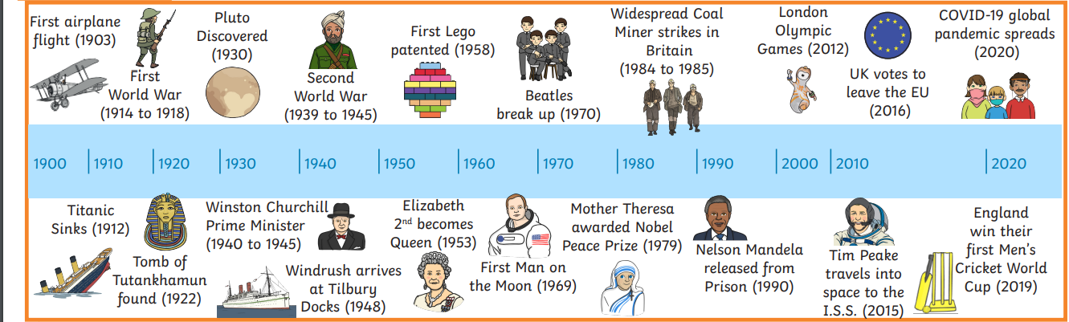 |  | - Know what happened on the two polar expeditions.  - Explain how the voyages were different  - Explain how the voyages were similar  - Start to explain the effects of the differences.

