Robins Class

M  O  N | R  e  g  i  s  t  e  r   | P  h  o  n  i  c  s  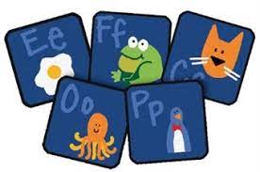 | Adult and child led activity  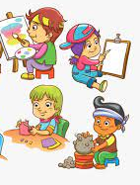 | H  a  n  d  w  r  i  t  i  n  g |  | P  l  a  y  t  i  m  e  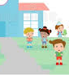 | Snack   | R  e  a  d  i  n  g  G  r  o  u  p  s | Adult and child led activities | L  u  n  c  h  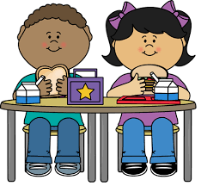 | Maths  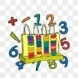 | Maths  Activity  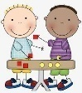 | P.E.  |  | PSHE   |  | Home time  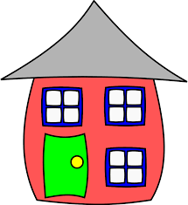
T  U  E |  |  |  |  |  |  |  |  |  |  |  |  | Bikes  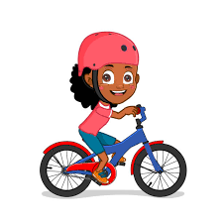 |  | Music  
W  E  D |  |  |  |  |  |  |  |  |  |  |  |  | 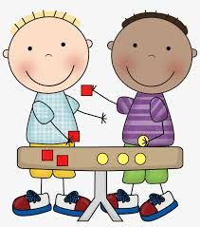  Maths Activity |  |  | Story/ Music to listen to
T  H  U  R |  |  |  |  |  |  |  |  |  |  |  |  | P.E. |  | Maths
F  R  I |  |  |  |  |  |  |  |  |  |  |  |  | Woods  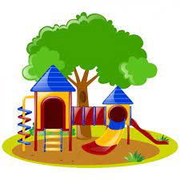 | R.E  |  | Awards  

