. |  | 8.45 – 9.00 | 9.00 – 10.00 |  | 10.05 – 11.00 |  | 11.15 - 12.15 |  | 1.15 – 2.15 | 2.15 – 2.20 | 2.45 – 2.50
Tuesday | Timestables  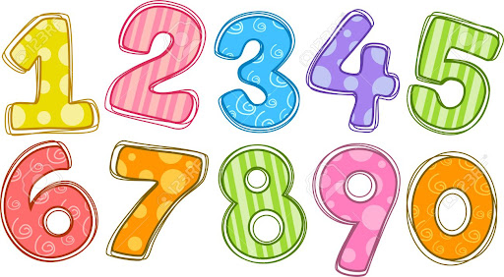 |  | English  Letter - hopes for Y3  Maths Y3-Place value   | Daily Mile | Getting to know you games   | Break | Art  All about me poster   | Lunch | PE   | PSHE - Class Rules  
Wednesday | Colour Kingfishers |  | Maths Y3-Place value | Daily Mile | English  Transition Booklet |  | History  Intorduction to Romans  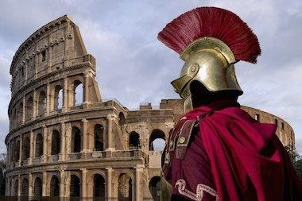 | Lunch | PE | Games | Singing Assembly
Please email me at jmuncey@sharnbrookprimary.beds.sch.uk of you have any questions.



