. |  | 9.00 – 9.20 | 9.20 – 10.15 |  | 10.30 – 11.25 | 11.35 - 12.05 |  | 1.00 – 1.10 | 1.10 – 2.00 | 2.00 – 2.45 | 2.45 – 2.50 | 3.10-3.20
Tuesday | Gruffalo Mask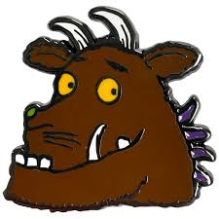 |  | Read the Gruffalo and create their own monsters  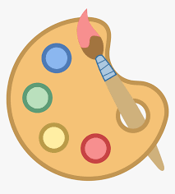 |  | Maths  Investigating number  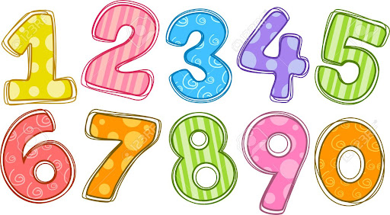 | Reading groups   |  | Paint monsters  MH readers |  | Create 3D Gruffalo character   |  | Story
Wednesday | Make Gruffalo child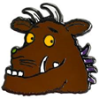 |  | Write a description of their monster   |  | Maths  Place value | Reading groups |  | Music  Singing  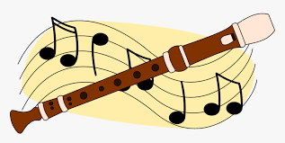 |  | Draw faces for Swift display | Assembly
Please email me at mheadley@sharnbrookprimary.beds.sch.uk of you have any questions.



