Tuesday | 8.45-9.00  Timestable colouring  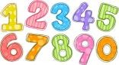 | 9.00-10.00  Introduction to myself and Mrs Sanders  Others to write a letter to me.  What I hope Y3 will be like, excited for. | 10.00  Daily  Mile | 10.00-11.00  Beach ball question game and hoop game outside.  Knot game.  Line up game  Nasty game with dice. Roll dice to see who can get the highest score.  Two truths and a lie. | B | 11.15-12.15  All about me.  Do a poster of interests, hobbies, favourite food etc. | L | 1.15-2.15  PE   | 2.15-3.00  Class rules to be made by the children on a flipchart piece of paper.  Online quiz Y2 Spellings.  TTR
Wednesday | Colour Kingfishers   | Maths transition booklet  TTR | Daily  Mile | English transition booklet   | B | Drawing Romans (Youtube)  Display for September.  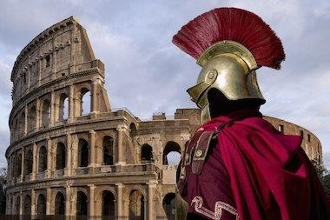  Bug in a rug | L | PE | Would you rather questions?  (Bit of fun)  Are we looking forward to year 3? What are we not sure about?

