Sharnbrook Primary Knowledge Planner - History
Key Question: What were the consequences of Henry VIII wanting a male heir?​ | Year: 5 | Disciplinary Focus: Cause and Consequence
People | Substantive Knowledge  Explain the key events of the Battle of Bosworth.  To know and understand how Henry VIII became king.  To explain the reasons behind Henry VIII having six wives.  To understand the cause and consequences of the English Reformation. | Vocabulary
  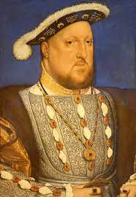 | Henry VIII  King of England
  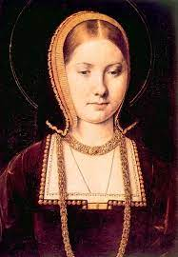 | Catherine of Aragon  1st wife | 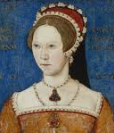 | Mary I  Henry and Catherine’s daughter
  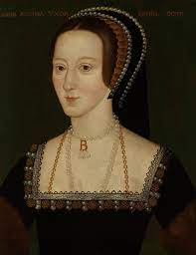 | Anne Boleyn  2nd wife | 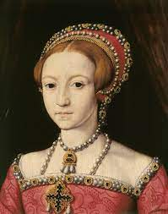 | Elizabeth I  Henry and Anne’s daughter
  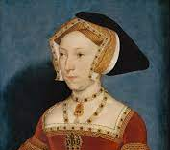 | Jane Seymour  3rd wife | 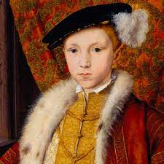 | Edward VI  Henry and Jane’s son
  Causation | To make something happen
  Consequence | What has occurred because of an event.
  Catholic Church | A church with the Pope in charge.
  Church of England | A protestant church with the king or queen in charge.
  Christianity | A religion that believes Jesus is the Son of God
  Chronology | The order in which things happen.
  Court | Those who serve the king or queen.
  Execution | The following through of a death sentence.
  King | A male ruler of a country who usually inherits his position and rules for life.
  Monarchy | A government with a single person at its head.
  Pope | The person in charge of the Catholic church.
What I should already know |  | Disciplinary Knowledge / How to be a historian
 |  | - Explain the reasons a male heir was so important to Henry VIII.  - To understand that not having a male heir had multiple consequences that impacted both England and wider.  - To understand that the consequences of one historical event can sometimes become the causes of another.
  A king is the head of the country.
  During the Gunpowder Plot the church was protestant but some people wanted it to be catholic.
Timeline
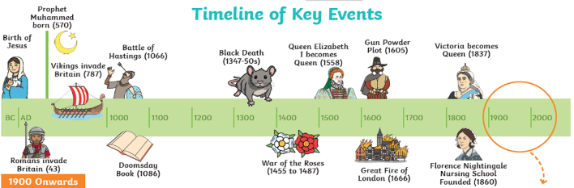

Sharnbrook Primary Knowledge Planner – History Year
Key Question: |  | Emphasis ie significance, change and continuity
What I should already know | Images / maps | Vocabulary
This should include what the children have covered previously in the tracked concepts such as power and monarchy if you are looking at that in this unit. |  | These should include the words you kindly highlighted on the history vocabulary list.
People
 |  | Disciplinary Knowledge / How to be a historian
 |  | Include the things that you want the children exhibit in their assessment.
 |  | Substantive Knowledge / Key knowledge
Timeline |  | Please include important knowledge that children will need to answer the key question.

