. | 8.50 – 9.15 |  | 9.15 – 10.15 |  |  | 10.30 – 11.30 | 11.30 - 12.05 |  | 1.00 – 1.10 | 1.10 – 2.00 | 2.00 – 2.45 | 2.50 – 3.10 | 3.10-3.20
Monday | Handwriting   |  | Maths  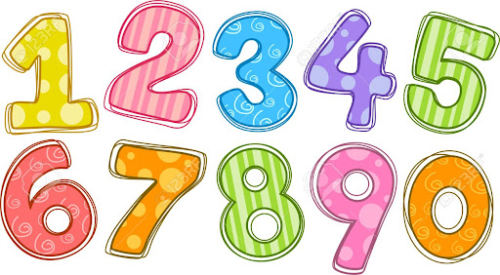 |  | Play | English | 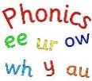 | Lunch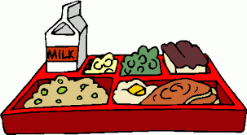 | Fred’s Reading | PE   | Computing  | Library  
Tuesday | Times tables |  | Maths |  | Play | English |  | Lunch | Fred’s Reading | 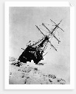  History |   Geography | Recorder  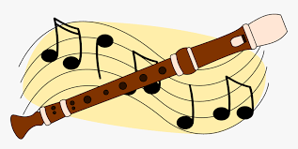
Wednesday | Maths mat |  | Maths |  | Play | English |  | Lunch | Fred’s Reading | Science   | RE   | Singing Assembly 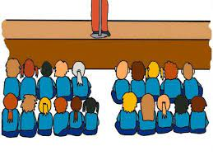
Thursday | Corrections | PE   |  | Spellings  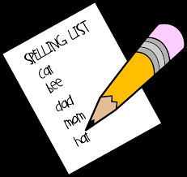 | Play | Maths |  | Lunch | Fred’s Reading | Art/DT   | PSHE   | Assembly
Friday | SpaG Mat |  | Maths |  | Play | English | Phonics | Lunch | Fred’s Reading | Comprehension / Reading   | Music | Celebration assembly

